Venture Ace LLC
Georgetown, Guyana
Tel: 223 – 8435 / 642 – 7173
Email: venture.ace.llc@gmail.com

ABOUT Venture Ace LLC

Venture Ace LLC was created to trade stock and shares on the US stock market. A strategy was created and tested to ensure profitability over long periods. We have established a partnership with a proprietary trading firm who will provide their resources towards to operation of our trading floor in return for a percentage of our trading profits. Our intention is to hire and train five traders who will be given access to a proprietary software and a six figure portfolio from which they will trade under the supervision of an experienced floor manager.

WHY WE ARE SO GOOD?
Our strategy takes advantage of small and definite increase in the price of a particular stock and converts it into a profit. The notion of a definite change along with larger portfolio provided by the broker allows one to profit from the sum invested. This strategy was implemented using a demo account and was perfected to be profitable on a daily basis.

MARKET
Trading will be done solely on shares being traded on the US stock market (NYSE, NASDAQ, and Amex). Clients will not be actively involved in the daily trading of shares, as our trading strategy will be implemented and executed in house. The number of shares to be bought is determined by the average volume as being able to sell the shares quickly is pivotal in making this strategy work.

BUSINESS MODEL & REVENUE MODEL
Revenues will derive from the purchase and sale of US stocks and shares on the daily basis. Number of shares bought will be determined by the average volume for the instrument being traded. The instruments are picked primarily on the companies receiving some form of good news, sorted based on the 52-week high / low and then those with low volume is eliminated These ten instruments are placed on a watch list and when an increase is detected, a purchase in the pre-determined number of shares is made, the price is monitored until it levels or drops at which time it is sold.

PARtner plan
We are proposing a total $50,000 capital investment in return for 50% stake in our company for 1 year, or a $50,000 unsecured loan at an interest rate of 5-10% per annum.. Your investment goes towards the setting up of an office complex for traders to operate, return on your investment will be a percentage of our estimated monthly profit of $30,000.

hOW INVESTMENT WILL BE USED
The $50,000 USD is intended for setting up and office complex for traders to operate and to run the office for three months until profitability is attained. Setup cost amount to $15,000 and operational cost for the first three months is $30,000 in total which leaves $5,000 for unexpected expenses. A detailed breakdown of these expenses as well and a breakdown of the estimated revenue can be found on the next sheet.

EXIT STRATEGY
A 50% stake in the company will give the investor an estimated ROI of $15,000 per month. At this rate we propose an exit strategy at end of 12 months at which time the invested sum will be purchased by the company or principal.

Set Up Costs

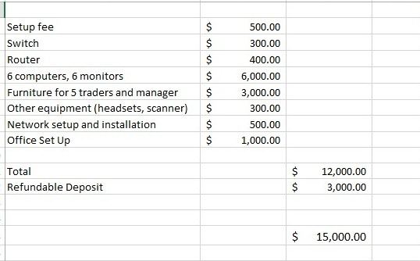

Monthly P&L (estimated)

