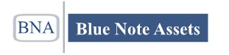

Construction Bridge Money
We Can Now Assist You With 100% Of Your Construction Costs
Close in 2 weeks
No minimum Credit Score
Funding from $100,000 to $1,000,000
Asset Types: Single Family, Multi Family, Apartment
Rates: 12-15%
No Prepayment Penalty
Interest Only
Points: 4-5
Term: 12 Months
Areas: VA, DC, MD, RI, MA, CT, PA, NY, NJ
How it works?
Shovel ready projects. Investor is reimbursed for costs by making draw requests. So investor must have cash to start and reimbursements take place in stages as requests are made. Work will be inspected before releases. Program primarily targets vertical construction. For acquisitions land is funded at 50% of cost.

Call To Get Funded
888-835-3640

