WINDSOR PROJECT

Executive Summary

Water Rights Sales
&
Land Development

11.2M Capital

30% Equity Position

Water Rights Sale
Investor ROI - 132%

or

Lease Water Sales (10 Year Lease)
Investor ROI - 88%

Executive Summary
Table of Contents

1. Executive Summary
- Abstract
- Financial Opportunity
- Project Overview
- Risk Factors
- Financial Summary and Overview
- Supportive Documents and Reports

Executive Summary

Abstract
The Windsor Water Project is an undeveloped property of 1,275 acres that controls an extremely valuable water asset of 3,000 acre feet of water that is independently documented through the “Recharge Statement” and the “Geohydrologic Reports”. The company has this property under a sales contract with the terms to purchase for $14,000,000, of which the negotiated terms are for 8M down and the seller to carry 6M. The property carries an appraised value of $20,975,000 taken in 2008, which was the low point in large land values and this appraisal was based only on raw land value and did not account for the established water asset, of which the previous owners, the appraiser or now the bank (the seller) have understood the value, demand or the marketability of this water asset. Additional value is attributed to this property as it represents one of the larger privately owned properties in Inyo County, of which only 1.7% of the entire county owned privately.
In addition to the water asset, this project has tremendous income potential from numerous other income streams involving Organic Agricultural Land sales, Alfalfa Land sales, Conservation & Wetlands Mitigation Banking, and Renewable Energy sales thru Solar Farm Leasing to the major power companies. These various income sources collectively make this a very multi-functional and sound investment which targets the primary essentials of water, Energy and Agricultural land. Collectively these income streams significantly enhance the projects composite value, and present a comprehensive economic land use plan with numerous exit strategies, coupled with additional flexibility, leveraging & negotiating aspects that ensure the project’s success and a 132% return on investment to the equity partner.
In this Business Plan and accompanying Sources & Uses Spreadsheet, we will incorporate only the Water Sales options, Organic Agricultural Land sales and the Solar Leasing income potential of the Project. In regards to the water asset with this project, first and foremost, this property has a claim to control 3,000 acre feet of water which is further established through independent pump testing the two wells on the property (represented in the Geohydrologic Report) and the independent safe yield verification through the “Recharge Statement”.
The Company has established numerous avenues for the marketing and the wheeling of this water asset to potential buyers throughout Southern California. This property has been brought under our control with a sales contract, which allows us to re-confirm the independent verification, the validity of the water rights title and the capacity of this particular water asset, and to begin the development and marketing of the water while still in escrow. The Company has options available to either close the water rights sale via a double escrow, or Leased water sale prior to the close of escrow, or secure financeable out-take contract(s) for the water. Our expenditures during escrow would be the cost of the legal expenses and operating capital costs for the marketing of the water asset.

The company is proposing to extend the existing sales contract to purchase the property which would carry an escrow period of 9 months in duration to allow an ample period to market the water and land assets as well as the other assets, however, we think it will take only 1-3 weeks to perform the asset Claim verification and then to begin marketing the assets. The refundable escrow deposit to extend the land purchase contract is $280K. The actual projected hard capital costs would be $2,000,000 which would include Asset Verification of $10,000 to verify the marketability of the water and confirm the water belongs to the property (seller has existing documentation of the water being controlled by the property). Once confirmation of the water asset is established, over the course of the escrow, we are budgeting an additional 120K for water contracts (legal expenses), and 600K for 12 months of overall project management (operating capital) which includes negotiating, escrow, verifications, water marketing, 600K for Engineering, consulting, permits, appraisal’s, fees, Cost of Capital, and a Contingency of 560K.
The presented Windsor project as presented offers a substantial and safe investment with a return of 132% to the equity partner. However, in addition to, and not currently factored into the Windsor Project business plan, are significant additional income sources that could be developed with the acquisition of this property and further research is conducted to develop the additional assets of this property.

  - First, there is a highly probable development of Geothermal Energy production on the site, of which there is Geothermic activity evident in the immediate area and needs to be further researched.
  - Secondly, the company can significantly expand the size of the property by leasing additional property from the Bureau of Land Reclamation (BLM) with in-expensive very long term leases. With one scenario, the Water can be supplied to these leased properties from the 1,275 acres. However, the company has been informed by the BLM that the Lessee can drill water wells on Bureau of Land Management leased land (outside of the 1,275 property), to supply water to the leased properties. This creates a significant increased development in the Windsor Project as the company can quadratically expand the size of the Windsor project:
    - Organic Agricultural land development on BLM leased property supplied with our developed water wells on BLM property. These leased properties can then be re-leased to Organic Growers for a significant return.
    - The company can implement Conservation & Wetlands Mitigation Banking development of these leased BLM lands.
    - The Company can significantly expand the Solar Farm on the leased BLM Property. The company can also remove the 475-acre solar development from the originally planned privately owned 1,275-acre property and thereby sell these 475 acres as the more lucrative Organic Farmland for 20K per acre and a total of $9.5M.
  - Thirdly, and more importantly, it is highly probable that the Windsor Project team can significantly generate site more acre feet of water than the historical 3,000 acre feet attributed to the 1,275-acre property. The company believes thru the 1,275 core acre footprint, that we can geologically access greater sources of water not competing with the aquifer providing the 3,000 acres’ feet of water historically attributed to the 1,275-acre property.

The Company is currently developing all three of these additional income streams. However, implementation the leasing of Bureau of Land Management (#2) and the aspect of the expanded water volume (#3) will drastically increase project income by a factor of 4 and the significantly increase the projects ROI over the currently projected 132%

B. Financial Opportunity
The Company is offering a 30% equity position in the Project for a $11,200,000 investment. The company projects a water rights sale of 3,000 acre feet of water at a very conservative value $15K per acre foot, which could generate over $45M when sold in the current market. Additionally, the company believes that the Windsor Project property can conservatively market in excess of 800 acres of virgin Organic Agricultural Crop land for $20,000 per acre for a total of 16M because this land is now supported with a viable water source. The remaining 478 acres of land will be allocated to development of the Solar Farms and will lease out at 1,000 per acre annually and 2.85M over the first 6 years.
With the Water sales and Organic Land Development sales alone, the projected Return on Investment for the Equity partner with a 30% holding in the project, would generate a 132% ROI at a 11.2M project investment price. However, the company will not purchase this property unless the project can close in escrow with water rights sales, or if binding water rights sales contracts are secured.
The company is projecting that the project will only require a $2,700,000 total initial investment over the course of the first year for the development of the asset, which includes all costs (refundable deposit, Asset Claim Verification Letter, operating capital, legal, Engineering-Consulting-Appraisals, and a Contingency), with the exception of the actual purchase of the property (closing cost). While in escrow the company can begin the marketing of the Windsor Projects Water Assets, Energy Assets (Solar) and Organic Agricultural land sales.

- Financial Overview
The overview of the current situation of the Windsor Project property is that the company believes we have multiple established concepts to market this water asset throughout California. In addition, we will develop and market the 800 acres of viable organic farmland for an additional $16M and designate 475 acres to lease out for solar development which will generate 2.85M over 6 years.
The Projected Return on Investment for the Equity partner with a 30% holding in the project would receive a 132% ROI with a 14M project purchase price for a Water Rights Sales, and an 88%. ROI with a 10 year Leased Water rights sale.

Expenses – First Year
$8,000,000 – Purchase Price 14M -owner to carry note of 6M (escrow Deposit $280K)
$ 75,000 – Interest on three months (25K per month)
$30,000 – Initial Asset Verification Legal. Letter verifying the Water Rights
$600,000 – Operating capital-project management, marketing, overhead, etc.
$200,000 –Well Installation-only upon guaranteed contracts for Water Sales.
$1,440,000 – Consulting, Engineering, Appraisals, Permits, Fees, Cost of Capital, etc.
$560,000 – Contingency (12 months)
$120,000 – Legal – Water attorneys, contract attorneys
$11,025,000 - Total Cost Investor

$14,140,000 – Total Cash Out - Expenses for first 6 Years

Water Asset Income –Gross Water Sales
$45,000,000 – 3,000 acre-feet of water at $15,000 per safe yield acre-foot.

Organic Farmland Resale Income
$16,000,000 - 800 acres at $20,000 an acre of Resale

Solar Lease
2,850,000 – 475 acres at $1,000 per acre per year over 6 years

$63,850,000 -Total Gross Income –utilizing Water, Solar & Agricultural profit centers only

$49,445,000 -Total Net Income –utilizing Water, Solar & Agricultural profit centers only

- Risk Factor Assessment
The Initial Hard Costs or initial actual risk capital necessary to bring this property under a purchase contact and to obtain a Water Asset Verification Letter verifying the water claim, and some operating capital to determine if this project will yield $45,000,000 is an initial capital risk of only $50K. In essence, this $50K Risk Capital cost would be comprised of the cost for the Initial Legal Opinion Letter along with some operating capital. With a favorable Water Asset Verification Letter, we can proceed with escrow and begin the marketing of the asset. A favorable Legal Opinion Letter in itself generates significant added value into the project.
The threshold point to proceed with this project would also be determined with the same initial Water Asset Verification Letter for the verification of the water asset claim. If the asset claim cannot be verified, the escrow is terminated, or the company could sell its position in escrow. With verification of the water asset claim, the company would then proceed with the project and could immediately begin the marketing of the total asset. Once again, these Water Rights that are projected to conservatively yield a net of $45M, can be determined with the initial hard costs of $50K. Only with the verification of the water asset claim, would the company proceed ahead with the marketing of that asset and then further development of the other assets that are inherent in the project as indicated at the beginning of this prospectus.
If the asset dos not support a favorable Water Asset Verification to market the water, but verifies the ownership of the water, the company has the option to either terminate escrow, or the company can decide to expand the Agricultural Land sales option in the project and to pursue the monetizing of the other options. Additionally, the company could sell its position to purchase in the property or double escrow the property, due to the fact that the company has already generated a significant added value to the property that could be marketed.

The Company is in contact with Water Buyers, Water Purveyors and Municipalities with express interested in the purchase of the water we intend to market as well as other Water Basins and Waterfields. The Water Asset can be marketed to numerous cities, water districts, private concerns, and large land development corporations that have expressed interest in purchasing water sources. The Company proposes to bring the property under sales contract, obtain a favorable legal opinion letter of the water asset and then begin marketing (open the bidding) of the Water Asset to the Water Buyers, Water Purveyors and Municipalities while the property is in escrow.

E. Financial Summary and Financial Overview

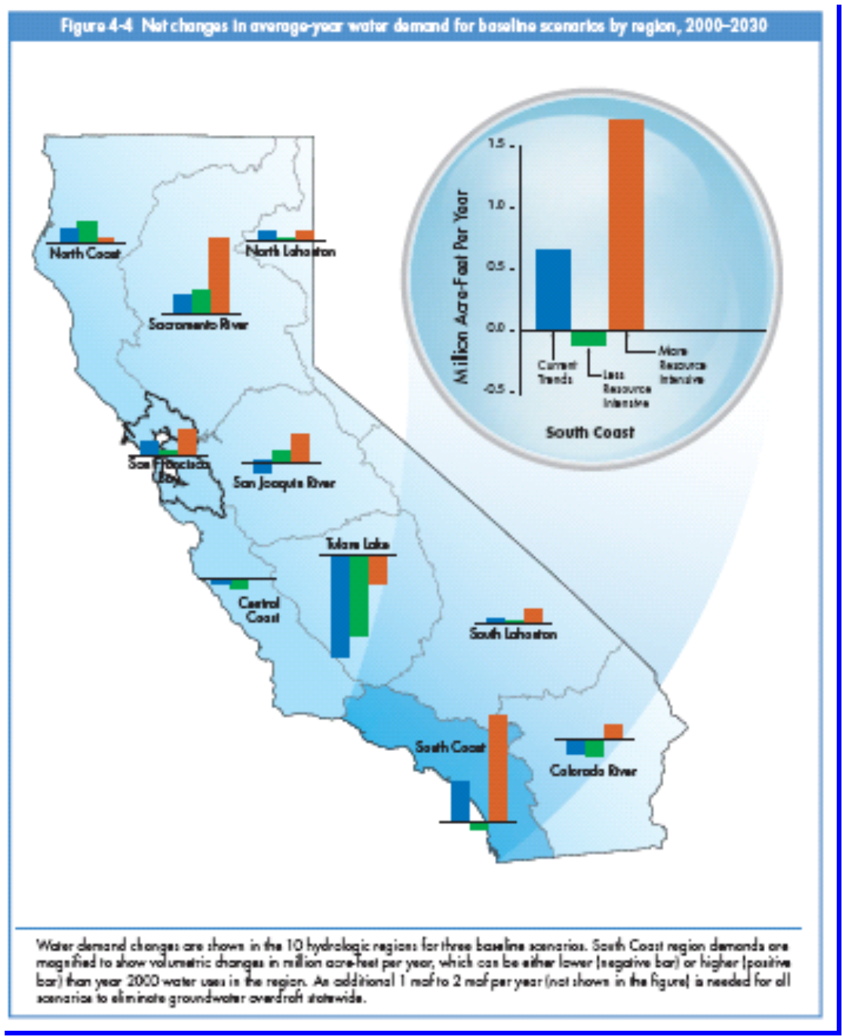
This Windsor Project with its multiple potential income sources (Agricultural Land, Solar, and Water assets) forms a comprehensive investment opportunity that is far greater than the sum of its parts. This multi-faceted investment package of 1,275 acres’ controls both 3,000 acre feet of water and development of prime organic agricultural land and renewable alternative energy sources thru solar development. Each of which represent important and essential natural resource, to the company and the country, and are continually increasing in demand and accruing in value.

Six Year Cash Flow
Water Rights Sales, Solar Leases and Organic Farmland Sales
Summary
Investment |  |  | $ 11,200,000
Water Rights Sales |  | $ 45,000,000
Lease Water Sales |  | $ -
Solar Lease Sales |  | $ 2,850,000
Land Sales |  | $ 16,000,000
Total Revenue |  | $ - | $ 63,850,000
Total Cash In |  |  | $ 75,050,000
Water Development Costs |  | $ 230,000
Land Acquisition Costs |  | $ 9,855,000
Project Development Costs |  | $ 3,320,000
Carrying Costs |  | $ 1,000,000
Total Cash Expenditure |  |  | $ 14,405,000
Net Cash Available |  |  | $ 49,445,000
Cash Distributions - Member Partners |  |  | $ 34,611,500
Cash Distributions - Investment Group |  |  | $ 14,833,500
 | Investment Group ROI - |  | 132%

F. Supportive Documents

- Recharge Statement
- The Geohydrologic Report
- Well Water Analysis Report
- The Phase I Environmental Report
- The Environmental Assessment (which represents the NEPA clearance from the US Dept. of Interior BLM)
- The General Biological Resources Report
- The Record of Survey Maps and Topography
- Geologic Hazard Review.
- Geologic Hazard Review Comments.

